# Copy others To be able to come up with something new

You have to copy others to be able to learn or study or to start something new.

* Character
* Adding colors _ color theory _ color schemas
* Detailing – adding shadows(cast shadow, form shadow), highlights,edge highlights(rim lights), ambient light, textures, gradient.

# Drawing with pen tool (p, click and drag + alt, alt + drag, ctl – temporary v or a )

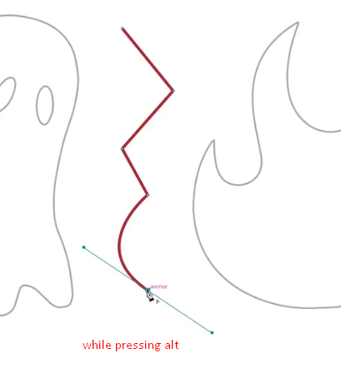

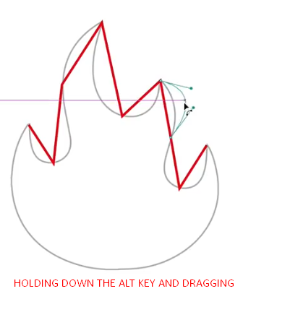

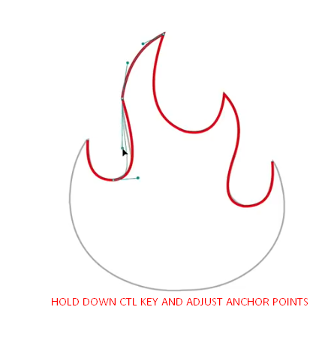

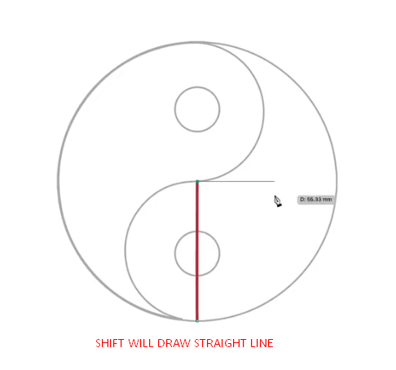

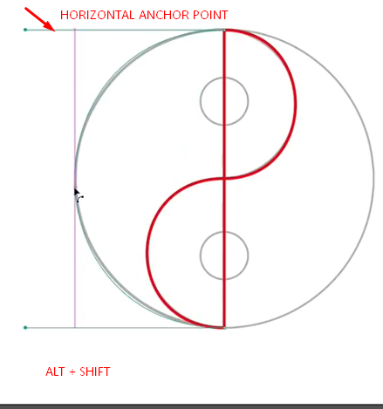

By pressing a

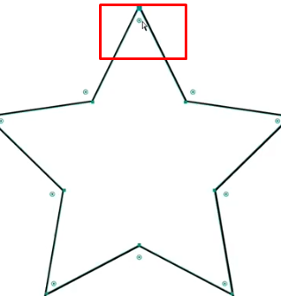

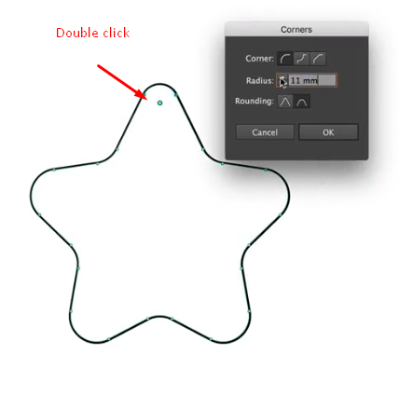

# Drawing Symmetrical Shape

Shift + x – swaps fill and stroke color 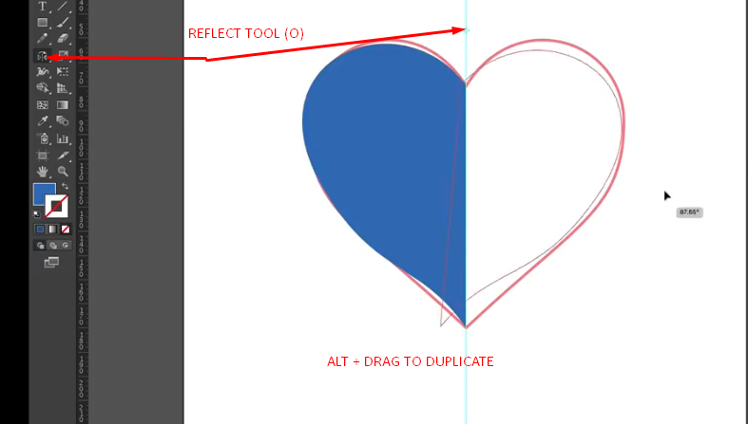

# Shape Builder

THEN USE SHIFT + M - SHIFT BUILDER TOOL

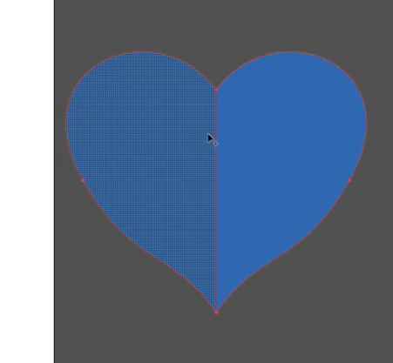

Every thing can be made from simple geomatric shape.

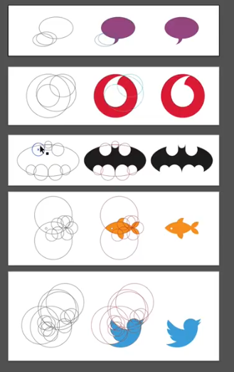

# Expand – turn strokes to fill

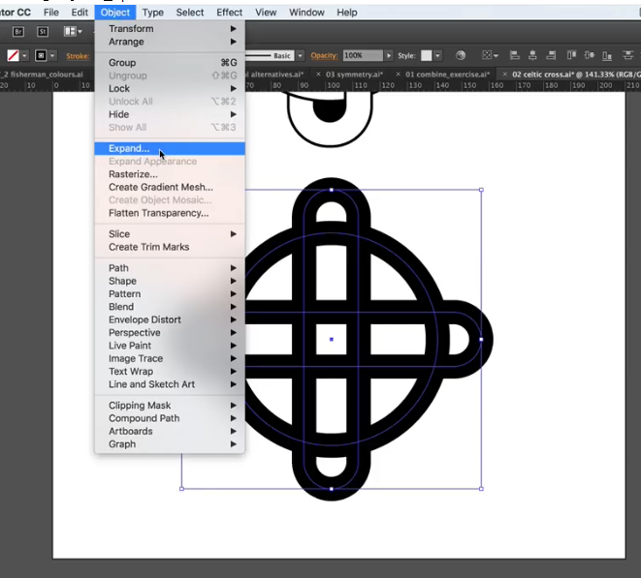

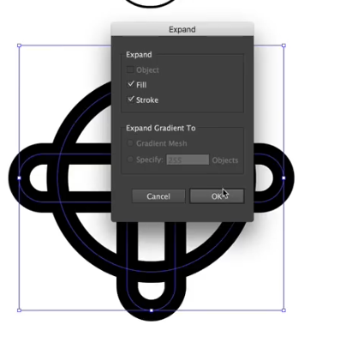

Now use shape builder on them 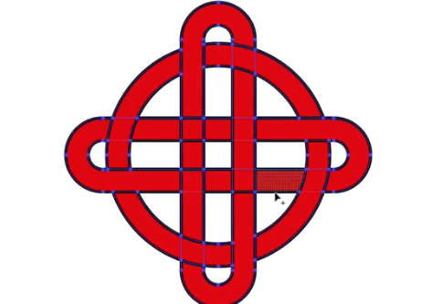

# Live Paint Bucket Tool

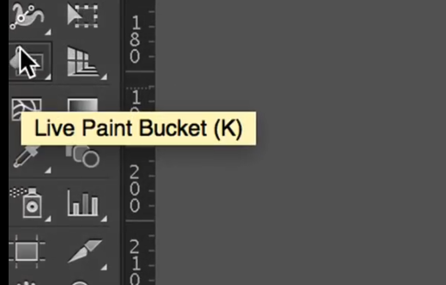

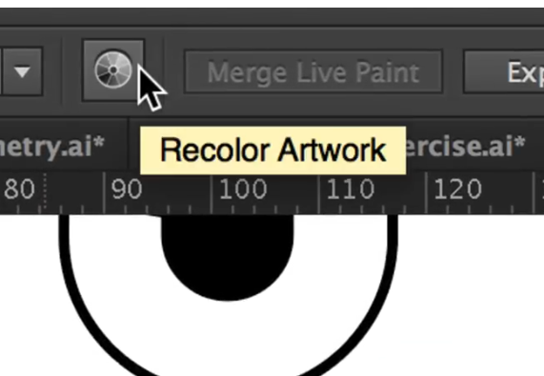

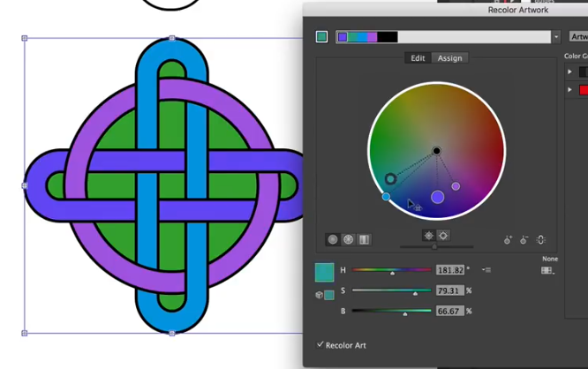

# Graphic Style

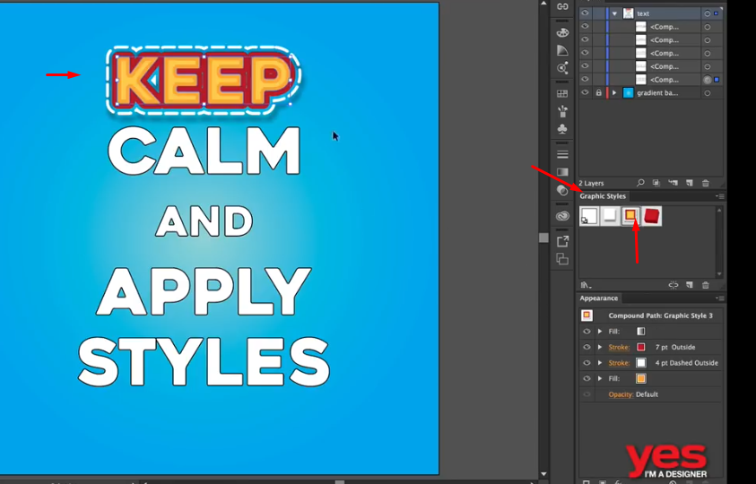

# Drawing with pencil tool (n)

You can draw over and over again and continue drawing.

Press alt to smooth path

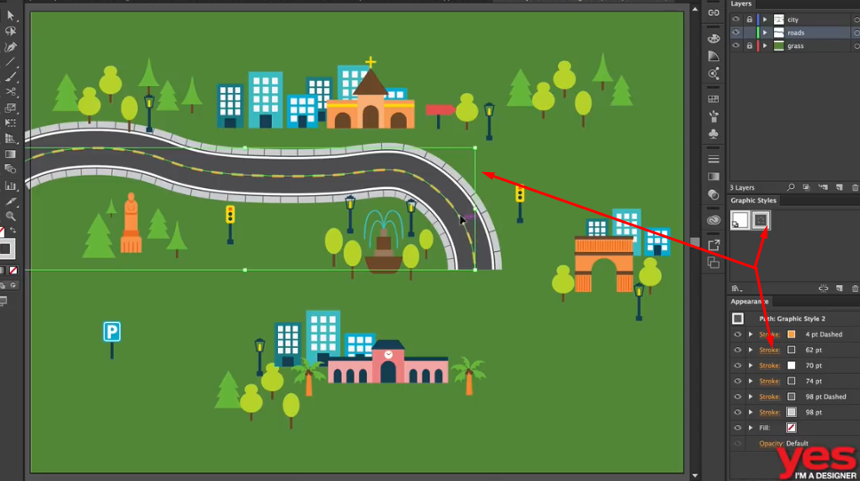

With the help of pencil tool (n) and graphics style.

# Shape Builder Tool

